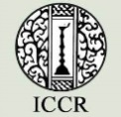
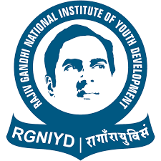
Three-day International Conference on
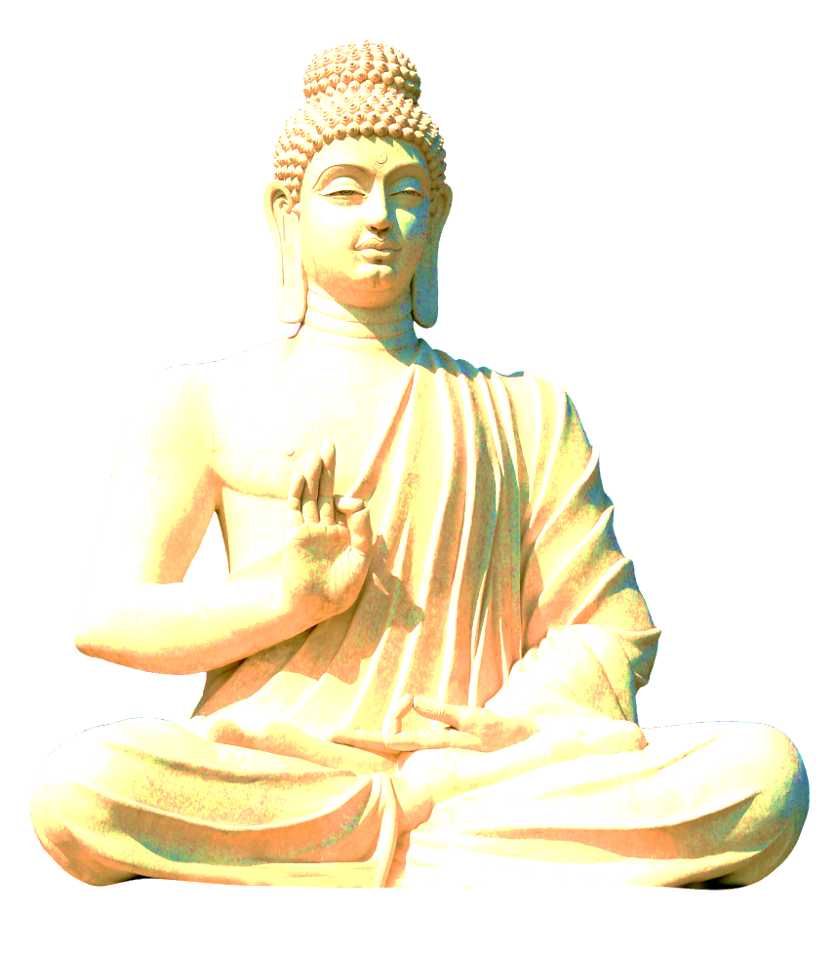
Buddhist Philosophy and Its Role In Inculcating Values Among Youth
(Feb. 17 -19, 2021)
Organized by

Rajiv Gandhi National Institute of Youth Development (RGNIYD)
Ministry of Youth Affairs and Sports, Government of India

In Association with

Indian Council for Cultural Relations
Ministry of External Affairs, Government of India

Inaugural Program
(February 17, 2021)

Feb. 17, 2021 15:00 – 15:30 pm (Indian Time)  Wednesday | Minute to Minute Program
Welcome address and objectives of the conference by  Prof. Sibnath Deb, Director, RGNIYD, MoYAS, GoI | 3 minutes | 15.00 pm  to  15.03 pm
Speech by Shri Asit Singh, IRS, Jt.Secretary, MoYAS, GoI | 4 minutes | 15.04 pm  to  15.07 pm
Speech by Shri Dinesh K. Patnaik, Director General, Indian Council for Cultural Relations, MoEA, GoI | 5 minutes | 15.08 pm  to  15.12 pm
Speech by Ms. Usha Sharma, IAS, Secretary, MoYAS, GoI | 6 minutes | 15.13 pm  to  15.18 pm
Presidential Address by Shri Kiren Rijiju, Hon’ble Minister, Ministry of Youth Affairs and Sports (Independent Charge) & Minority Affairs, GoI | 10 minutes | 15.19 pm  to  15.28 pm
Vote of Thanks by Prof. Vasanthi Rajendran, Head, CTO&CB, RGNIYD, MoYAS, GoI | 2 minutes | 15.29 pm  to  15.30 pm

Technical Sessions (Feb.17, 2021, Wednesday)

Day -1 | Technical Sessions | Topic
15.30 - 16.00 Hrs | Prof. C. Upender Rao  Special Centre for Sanskrit Studies,  Jawaharlal Nehru University,  New Delhi, India | The message of Buddha to the youth.
16.00 - 16.30 Hrs | Ven. Gathare Chandananda Thero  Sri Lanka | Buddhism - Beliefs and Practices among Sri Lankan youth.
16.30 – 17.00  Hrs | Prof. K.T. S. Sarao  PhD (Delhi); PhD (Cantab); DLitt (HC)  Professor and Head  Department of Buddhist Studies  University of Delhi, Delhi-110007  India | Buddhist Philosophy: Its Relevance in Today's Globalizing World.
17:00 – 17:30 Hrs | Prof. Dr. Hridaya Ratna Bajracharya  Vice – Chancellor, Lumbini Buddhist University  Parsa, Lumbini, Nepal | Vision of Gautam Buddha and its Relevance Today.
Day 2 | Technical Sessions (Feb.18, 2021, Thrusday)
10.30 – 11.00 Hrs | Ven. Dr. (Venerable Doctor) Thich Nguyen Dat  Senior Lecturer on Buddhist Philosophy & Buddhist Psychology  Vietnam Buddhist University, Vietnam | "Vietnam Buddhist Education - A Channel of Cultural Exchange between and among Vietnam, India and other countries".
11:00 – 11:.30 Hrs | Dr. Nidup Dorji  Department of Public Health  Faculty of Nursing and Public Health  Khesar Gyalpo University of Medical Sciences of Bhutan, Thimphu, Bhutan | Buddhism: Why it matters to us?
11.30 – 12.00 Hrs | Dr. Sonam Chuki, PhD  Curriculum developer (History education)  Royal Education Council  Paro, Bhutan | Rediscovering basic goodness: Boundless ways of being authentic in the global world
12.00 – 12.30 Hrs | Prof. Bimalendra Kumar  Department of Pali and Buddhist Studies,  Banaras Hindu University (BHU),  Varanasi (UP), India | Concept Of Mindfulness (Smṛti) in Buddhism and its Relevance to Contemporary Youth
12.30 - 13.00 Hrs | Mr. Say Amnann, Deputy Director General of Religious Affairs. (MoCR), Cambodia | Teachings of Buddha and its Relevance to the Youth of Cambodia
13:00 – 14:00 Hrs | Break
14.00 - 14.30 Hrs | Dr. Rajitha P. Kumara  Senior Lecturer, Deptt. Of Pali & Buddhist Studies University of Kelaniya, Kelaniya, Sri Lanka | Early Buddhist Theory of Cognitive Development and its influence on the Individual
14.30 – 15.00 Hrs | Ven. Baasanbat Bayanbold  Mongolia | Buddha Shakyamuni’s Law of Karma – Ethical Development and Conflict Resolution
15:00 – 15:30 Hrs | Ven Phra Anandapanyo  Thailand | “How Buddhism is hidden in video games?" & Its influence on the Youth.
15.30 - 16.00 am | Dr. Amarjiva Lochan  Associate Professor  Ancient Indian History and Culture  Shivaji College  University of Delhi, India | Buddhism – Beliefs and Practices among Indian youth.
16:00 – 16:30 Hrs | Dr. Suresh Kumar  Assistant Professor, Department of Buddhist Studies  Nava Nalanda Mahavihara, India | Significance of Values in Shaping the Personality of Youth – Role of Buddhist Philosophy.
16:30 – 17:00 Hrs | Dr. Arvind Kumar Singh  Head & Assistant Professor  School of Buddhist Studies and Civilization &  Director, International Affairs  Gautam Buddha University,  Greater Noida, Uttar Pradesh-201308, India | Beliefs and Practices among Youth as an outcome of the Impact of Buddhist Philosophy.
Day 3 | Technical Sessions (Feb.19, 2021, Friday)
10.30 – 11.00 Hrs | Dr. Sombat Mangmeesukhsiri  Director- Sanskrit Studies Centre,  Deptt. of Oriential Languages,  Silpkorn University,  22 Boromarachachonnani Road, Talingchan, Bangkok, Thailand | Buddhism and Youth in Thailand: Past, Present and Future
11.00 – 11.30 Hrs | Mr. Keo Khanteymethea,  Director of International Cooperation.  (MoCR)
11.30-12.00 Hrs | Ven. Pusselle Wineetha Thero  Sri Lanka | Influence of Buddhist Philosophy among the Youth in Sri Lanka.
12.00 – 12.30 Hrs | Ven. Munkhbaatar.B | The Compassionate Meditation and Its Values in Modern Time
12.30-13.00 Hrs | Prof. V.K. Singh  Professor of Tibetan and Buddhist Studies, Department of Chinese and Tibetan Languages, Punjab University, Chandigarh, India | Core Values and Perspectives of Buddhism for Youth Development.
13.00 – 13.30 Hrs | Dr. Rana Purushottam Kumar Singh  Assistant Professor  Nava Nalanda Mahavihara (Deemed University),  Nalanda-803111, India | Eight Fold Path of Buddha – Message to the Youth.
13.30 – 14.30 Hrs | Lunch Break
14.30-15.00 | Dr. Fr. Soosai Lawrence S.J.,  Jeevan Sangham,  Dumuhan, Bodhgaya,  Bihar, India | Life and Philosophy of the Buddha: An Inspiration for Modern Youths!
15.00-15.30 | Dr. Mukesh Kumar Verma  Associate professor  Nava Nalanda Mahavihara  Nalanda, Bihar, India | Buddhism - Beliefs and Practices among Indian youth.
15.30 – 16.00 Hrs | Valedictory Function  Vote of Thanks

