Indian Culture Scholarship by ICCR for the Academic Year 2021-2022

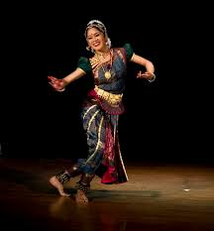 |  | 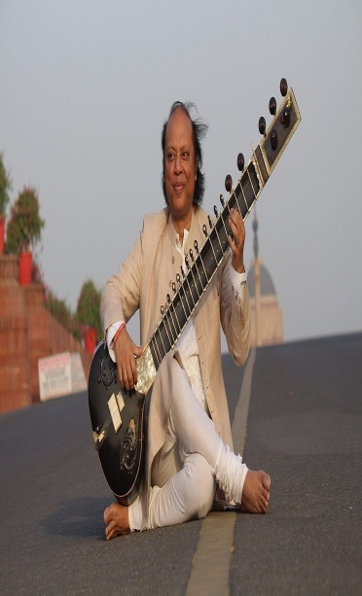

The Indian Council For Cultural Relations (ICCR) is offering scholarships for study of Indian classical music, dance, painting, yoga and sculpture at Indian universities/institutes in the academic year 2021- 22, including in the Guru-Shishya Tradition of learning systems in India straight from the maters of various classical dance and music (vocal and instrumental) of India. This Scholarship Scheme is offered to nationals of all countries.

The Guru (Teacher) -Shishya (Student) Parampara (Tradition) is a unique system of imparting education in one or one teacher student learning environment passed from generation since ancient times. This involves tradition of a living and learning relationship between the Guru and the Student (Shishya), signifies emotional, intellectual, and spiritual bond between them.
Under this scheme, applicants will have the option to apply to five universities/ institutes in the order of their preference of study. Applicants are requested to log onto “Admissions to Alumni” (A2A), the Scholarship Portal developed by ICCR at http://a2ascholarships.iccr.gov.in/. This portal contains all the relevant information for the applicants including details of all State Universities, Central Universities and Institutes, colleges affiliated with them, courses available, availability of hostels, applications guidelines, eligibility criteria and other relevant information for helping the applicants in decision-making while applying for the academic courses of their preference.

The admission for the Academic Year 2021-2022 is operational from 15 March 2021. The application from Interested students between 18 to 30 years of age is invited through A2A Scholarship Portal at http://a2ascholarships.iccr.gov.in. The Scholarship covers the following: (i) Payment of Tuition fees/Registration Fees; (ii) Economy class air fares; (iii) Boarding and Lodging; and (iv) Living Allowance to meet Hostel and food catering charges.
Last date of submission of online Application at http://a2ascholarships.iccr.gov.in/ is 30 April 2021. The guidelines and procedure for applications is available on the A2A Portal.
**

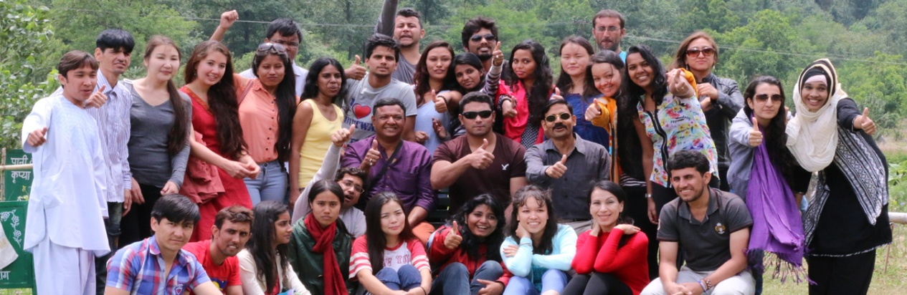
INDIAN COUNCIL FOR CULTURAL RELATIONS (ICCR) SCHOLARSHIP SCHEME FOR 2021-22 WITHOUT AIRFARE
General Scholarships Scheme—GSS
The General Scholarship Scheme (GSS) is one of the most popular schemes of the ICCR for foreign students. Scholarships are awarded under this scheme annually to international students from various countries, including Slovenia for the undergraduate, postgraduate degrees and for pursuing research at M Phil and Ph D level in any course ranging from humanities, management, law, yoga, dance, music, fashion and architecture etc. (except for medicine) in leading Indian universities and institutes.
Offer of ICCR Scholarship for the Academic Year 2021-22
ICCR has offered one slot to Slovenia under the GSS Scheme for the academic year 2021-22. Applications are invited from Slovenian nationals wishing to pursue higher studies in Indian universities and higher educational institutions at under-graduate, post-graduate or a doctoral/post-doctoral level under ICCR General Scholarship Scheme for the academic year 2021-22.
This scholarships cover enrolment and course fees, besides grant of a fixed amount of living expenses, on quarterly basis, to the approved scholar/student. In order to ensure security of the foreign students, ICCR advises to students to stay in hostel, if available. However, students are allowed to stay in private accommodation if the concerned institute does not insist on staying in their hostel. The scholarships are granted for the full duration of the course.
The eligible students need to apply at the ICCR scholarship portal - A2A (Admission to Alumni) Scholarship portal - http://a2ascholarships.iccr.gov.in The portal contains all the relevant information for the applicants, including details of all participating Universities, colleges affiliated with them, courses offered, availability of hostels, application guidelines, eligibility criteria and other relevant information for helping the applicants in decision-making while applying for the academic courses of their preference.
Eligible students wishing to submit their applications are advised to carefully go through the courses offered by the Universities before finally submitting the application form. List of universities where ICCR students are currently studying is available at ICCR’s website www.iccr.gov.in. Applicants are required to submit a medical fitness certificate from the recognised hospital in the prescribed format available with the online application form.
Completed applications need to be submitted latest by 30 April 2021 through the A2A Scholarship portal. The A2A scholarship Portal is operational from 15 March 2021 for foreign studetns to apply for admission. Short-listed candidates will have to undergo an English Proficiency Test, followed by an interview, details of which will be communicated to them in due course.
Prospective students should be 18 years of age at the time of admission in Indian Universities/Institutes and not more than 30 years of age.
**

